Packet Tracer – Skills Integration Challenge

1. Topology

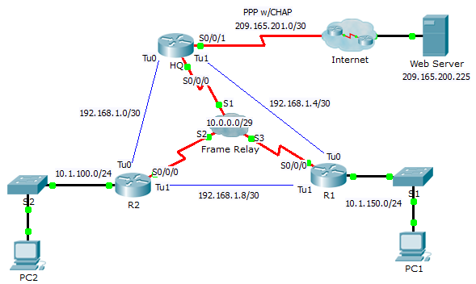

1. Addressing Table

|  |  |  |  |  |
| --- | --- | --- | --- | --- |
| Device | Interface | IPv4 Address | Subnet Mask | **Default Gateway** |
| HQ | S0/0/0 | 10.0.0.1 | 255.255.255.248 | N/A |
| S0/0/1 | 209.165.201.2 | 255.255.255.252 | N/A |
| Tu0 | 192.168.1.1 | 255.255.255.252 | N/A |
| Tu1 | 192.168.1.5 | 255.255.255.252 | N/A |
| R1 | G0/0 | 10.1.150.1 | 255.255.255.0 | N/A |
| S0/0/0 | 10.0.0.3 | 255.255.255.248 | N/A |
| Tu0 | 192.168.1.6 | 255.255.255.252 | N/A |
| Tu1 | 192.168.1.9 | 255.255.255.252 | N/A |
| R2 | G0/0 | 10.1.100.1 | 255.255.255.0 | N/A |
| S0/0/0 | 10.0.0.2 | 255.255.255.248 | N/A |
| Tu0 | 192.168.1.2 | 255.255.255.252 | N/A |
| Tu1 | 162.168.1.10 | 255.255.255.252 | N/A |
| Web | NIC | 209.165.200.226 | 255.255.255.252 | 209.165.200.225 |
| PC1 | NIC | 10.1.150.10 | 255.255.255.0 | 10.1.150.1 |
| PC2 | NIC | 10.1.100.10 | 255.255.255.0 | 10.1.100.1 |

1. DLCI Mappings

|  |  |  |  |
| --- | --- | --- | --- |
| **From / To** | **HQ** | **R1** | **R2** |
| **HQ** | - | 103 | 102 |
| **R1** | 301 | - | 302 |
| **R2** | 201 | 203 | - |

1. Background

This activity allows you to practice a variety of skills, including configuring Frame Relay, PPP with CHAP, NAT overloading (PAT), and GRE tunnels. The routers are partially configured for you.

1. Requirements

Note: You only have console access to router R1 and telnet access to router HQ. The username is **admin** and the password is **adminpass** for telnet access.

R1

* Configure full mesh Frame Relay.
  1. Configure Frame Relay encapsulation.
  2. Configure a map to each of the other routers.
  3. The LMI type is ANSI.
* Configure GRE tunnels to the other routers.
  1. Configure the source port and the destination address.
  2. Configure the IP address for the tunnel interface according to the **Addressing Table**.

HQ

* Configure **HQ** to use PPP with CHAP on the link to the Internet. **ISP** is the router hostname. The password for CHAP is **cisco**.
* Configure GRE tunnels to the other routers.
  1. Configure the source port and the destination address.
  2. Configure the IP address for the tunnel interface according to the **Addressing Table**.
* Configure NAT to share the public IP address with the entire class A private range.
  1. Configure access-list 1 for use with NAT.
  2. Identify the inside and outside interfaces.

Verify End-to-End Connectivity

* All end devices should now be able to ping each other and the **Web Server**.
* If not, click **Check Results** to see what configurations you may still be missing. Implement necessary fixes and retest for full end-to-end connectivity.